Module 9: Assignment-Working with Raw SQL in pgAdmin

Docker Compose Setup:
version: '3.8'

services:
# Service: web
web:
build: .
container_name: fastapi_calculator
ports:
- "8000:8000"
volumes:
- .:/app
environment:
PYTHONDONTWRITEBYTECODE: 1
PYTHONUNBUFFERED: 1
DATABASE_URL: postgresql://postgres:postgres@db:5432/fastapi_db
command: uvicorn main:app --host 0.0.0.0 --port 8000 --reload
depends_on:
- db
networks:
- app-network

# Service: db (PostgreSQL)
db:
image: postgres:15
container_name: postgres_db
environment:
POSTGRES_USER: postgres
POSTGRES_PASSWORD: postgres
POSTGRES_DB: fastapi_db
ports:
- "5432:5432"
volumes:
- postgres_data:/var/lib/postgresql/data
healthcheck:
test: ["CMD-SHELL", "pg_isready -U postgres"]
interval: 10s
timeout: 5s
retries: 5
networks:
- app-network

# Service: pgadmin
pgadmin:
image: dpage/pgadmin4 # Updated to a newer version
container_name: pgadmin
environment:
PGADMIN_DEFAULT_EMAIL: admin@example.com
PGADMIN_DEFAULT_PASSWORD: admin
ports:
- "5050:80" # Ensure port 5050 is free or change if necessary
volumes:
- pgadmin_data:/var/lib/pgadmin
depends_on:
db:
condition: service_healthy
networks:
- app-network

volumes:
postgres_data:
driver: local
pgadmin_data:
driver: local

networks:
app-network:
driver: bridge

SQL command executions in pgAdmin showing successful table creation, data insertion, queries, updates, and deletions.

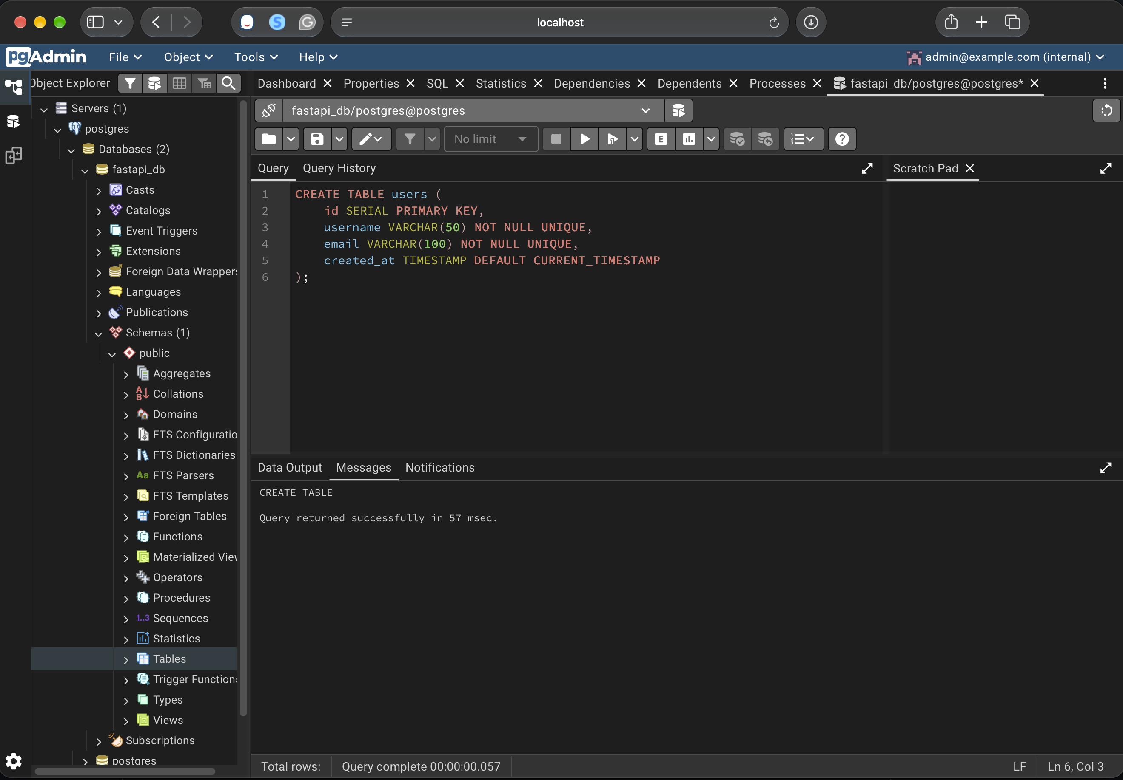
(A) Create Tables:
Table Creation: ‘users’ table
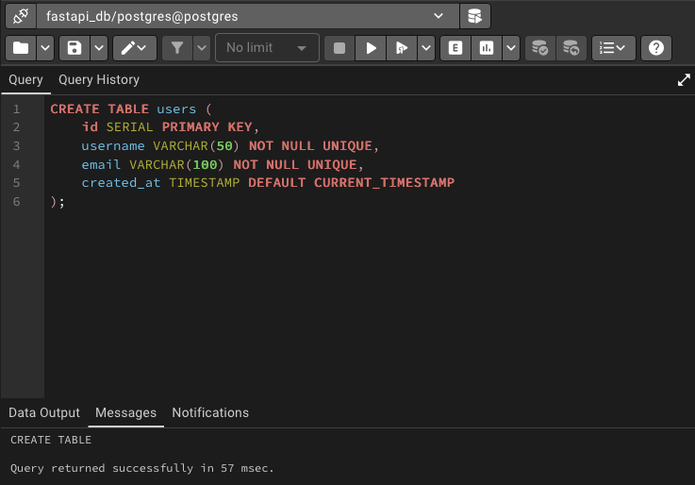

Table Creation: ‘calculations’ table
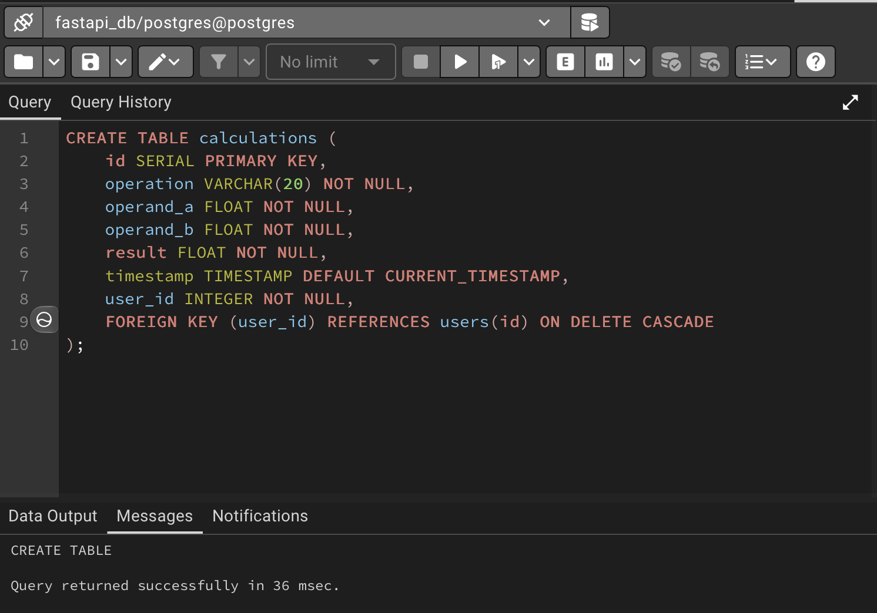
Showing Tables calculations and users that are created.
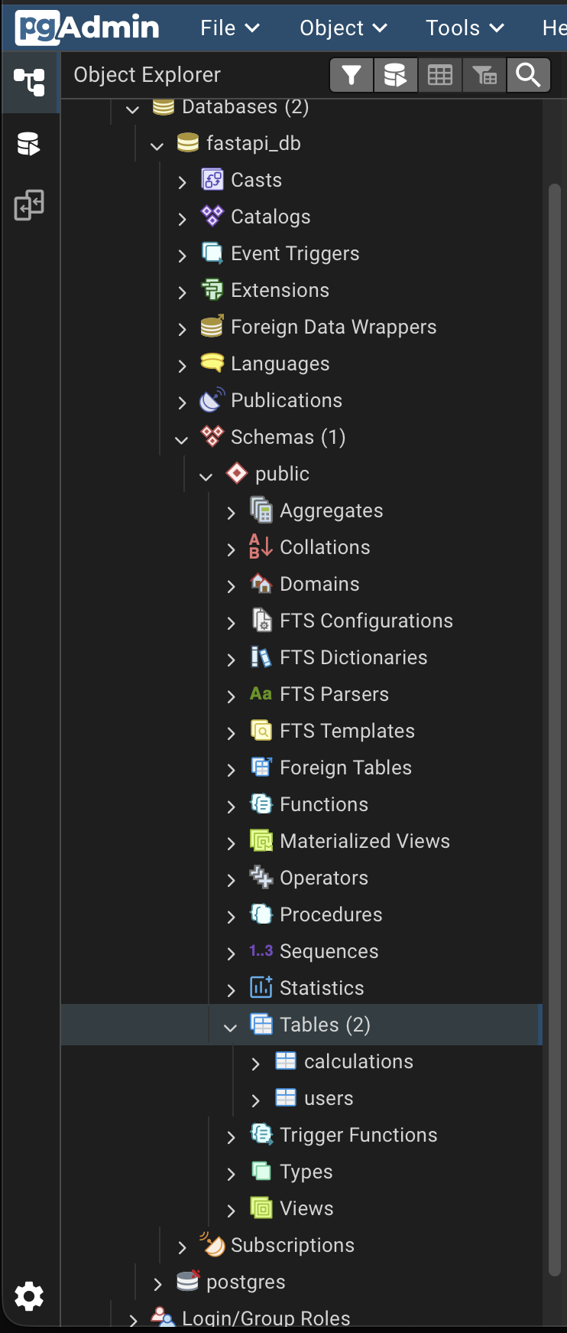

(B) Insert Records
Inserting Records into ‘users’ table
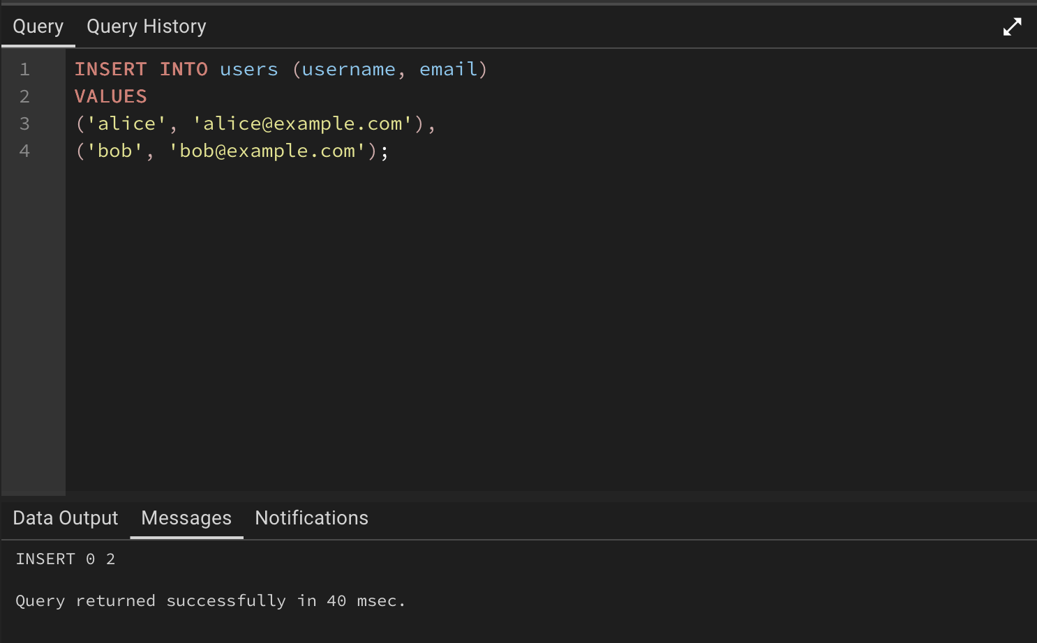

Inserting Records into ‘calculations’ table

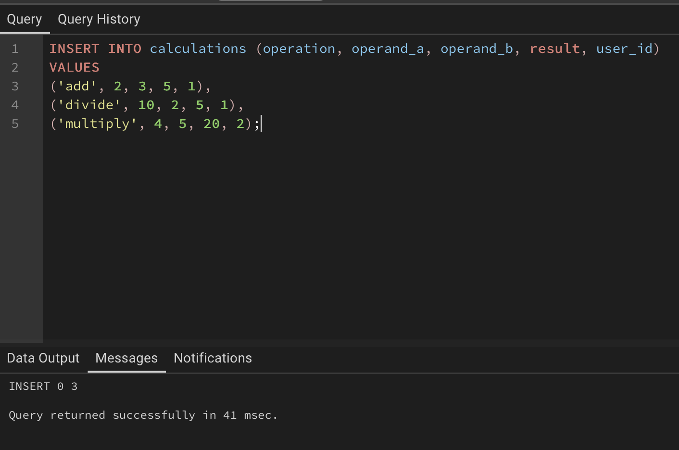

(C) Query Data

Retrieve all the users

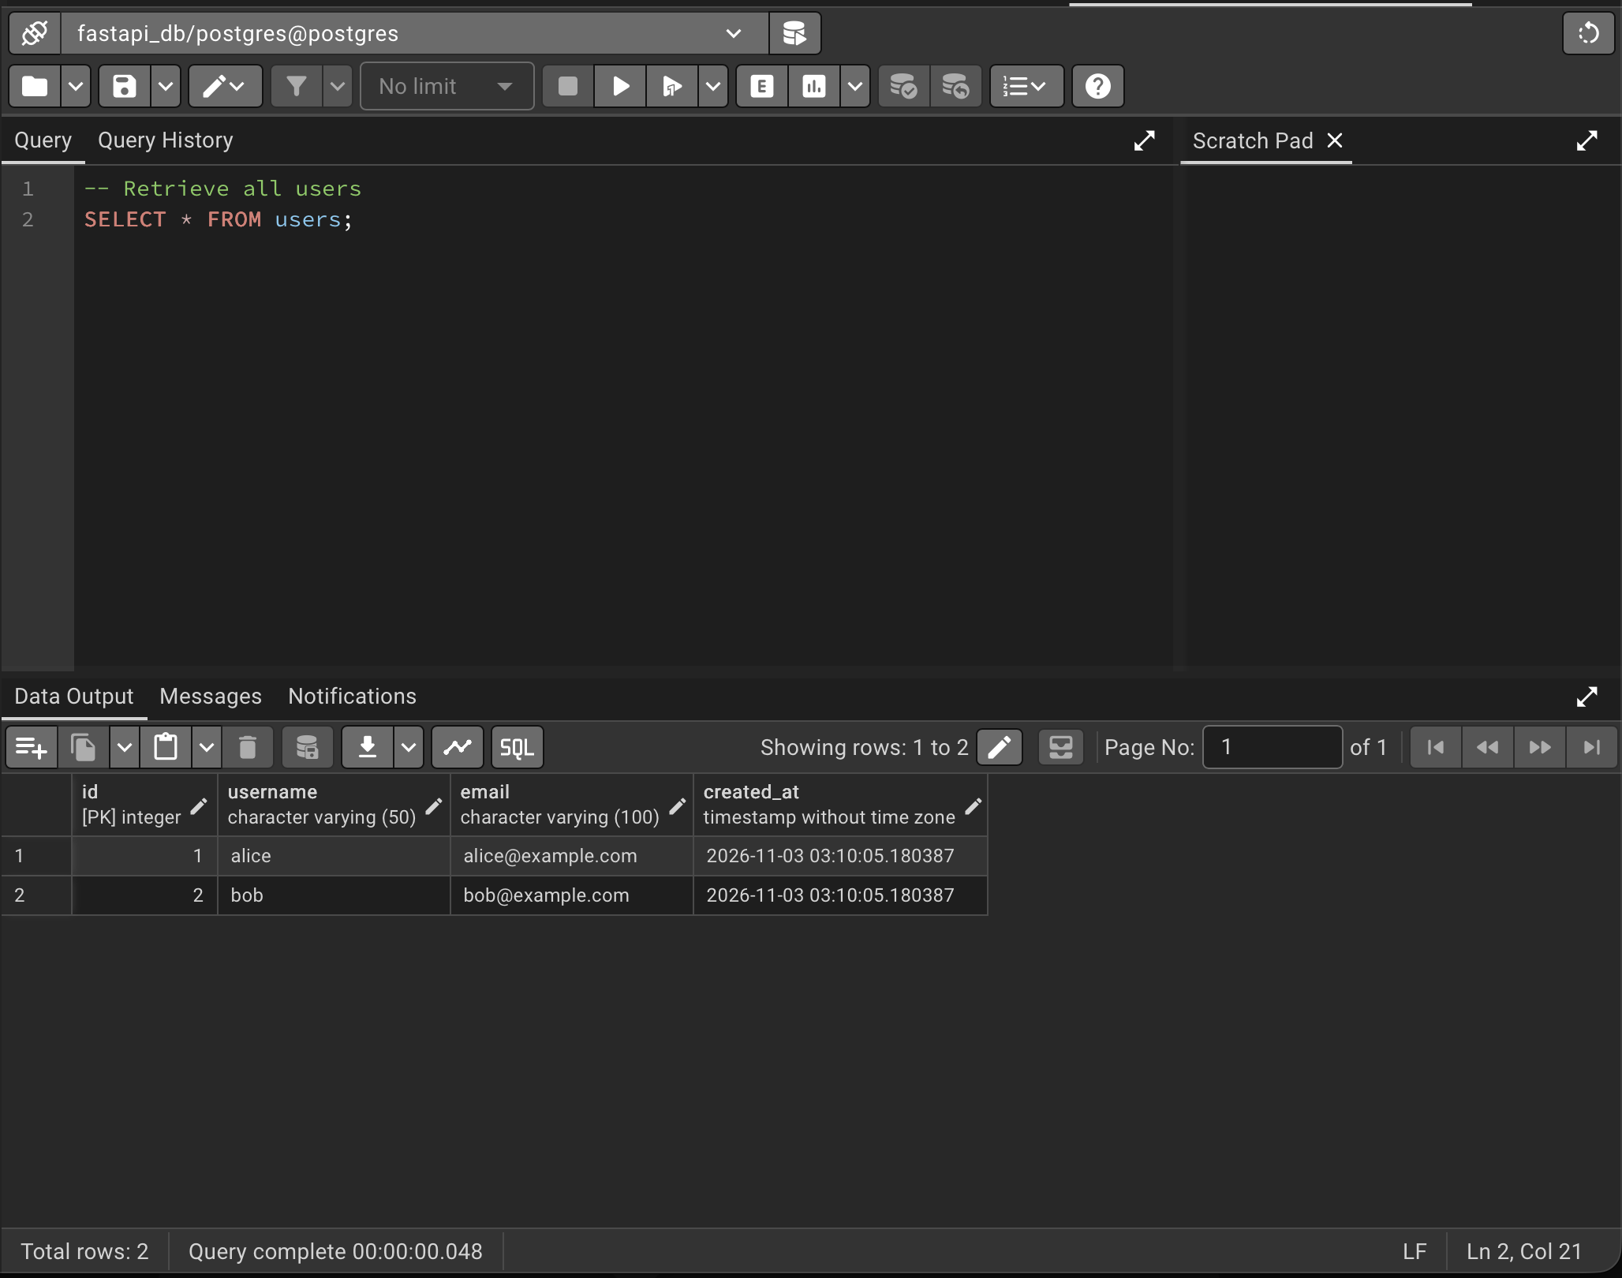

Retrieving all calculations that are in the table
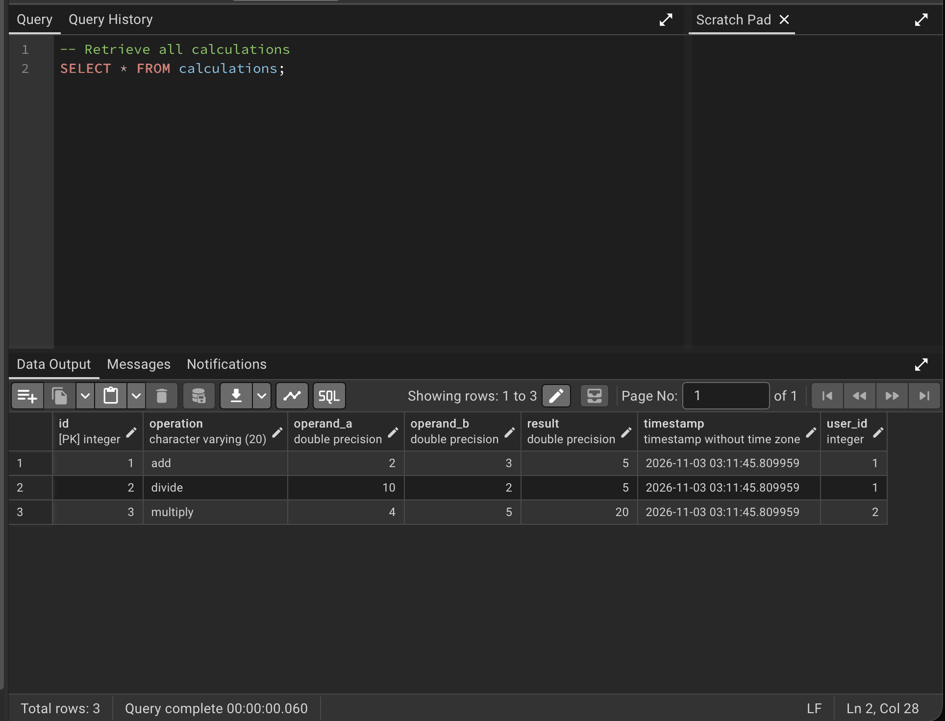

Join users and calculations table and retrieving selected columns from the
respective tables
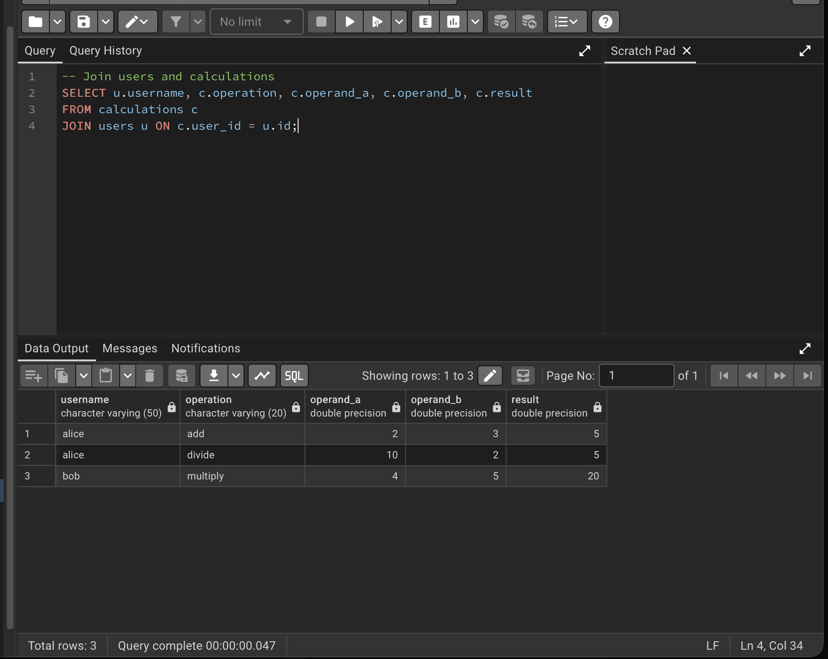

(D) Update a Record
Updating table ‘calculations’ for id - 1 with result as 6
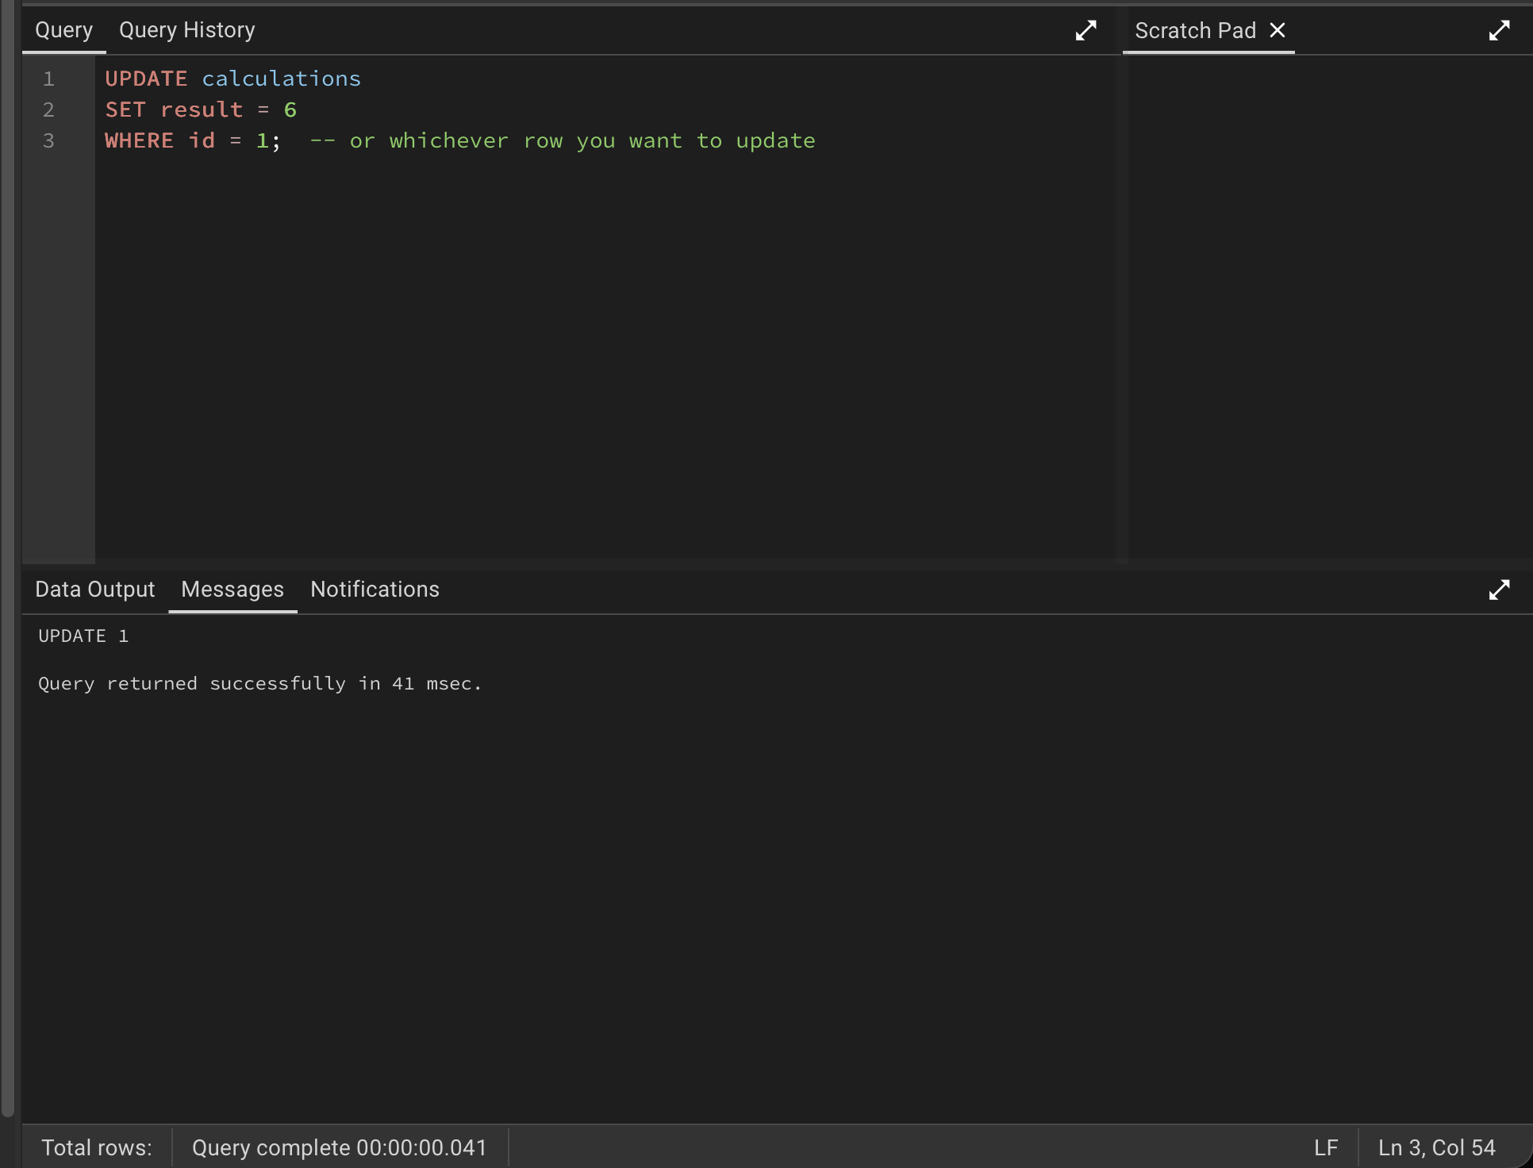

(E) Delete a Record
Deleting a row from ‘calculations’ table for id -> 2
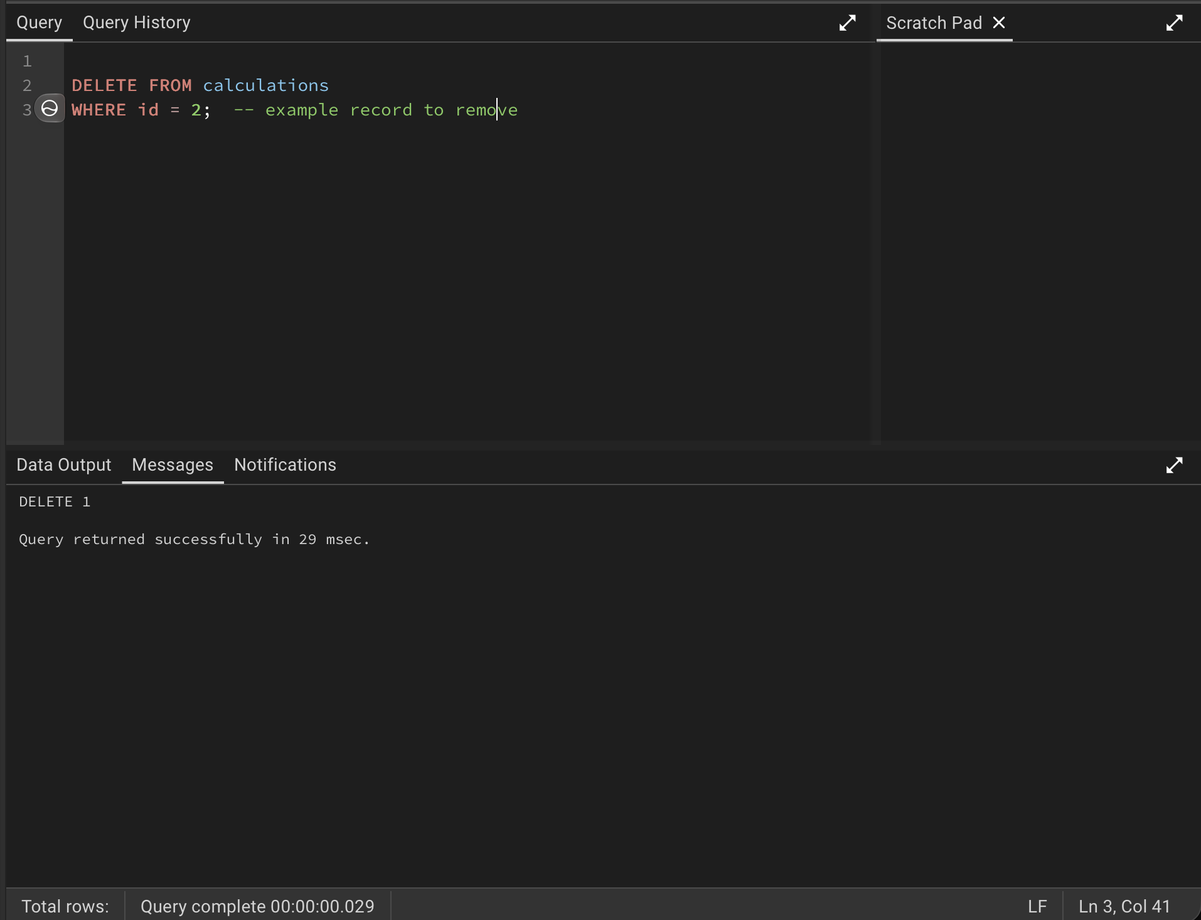

Data in ‘calculations’ table after we deleted the row with id – 2 and u[dating the result as 6 for id - 1
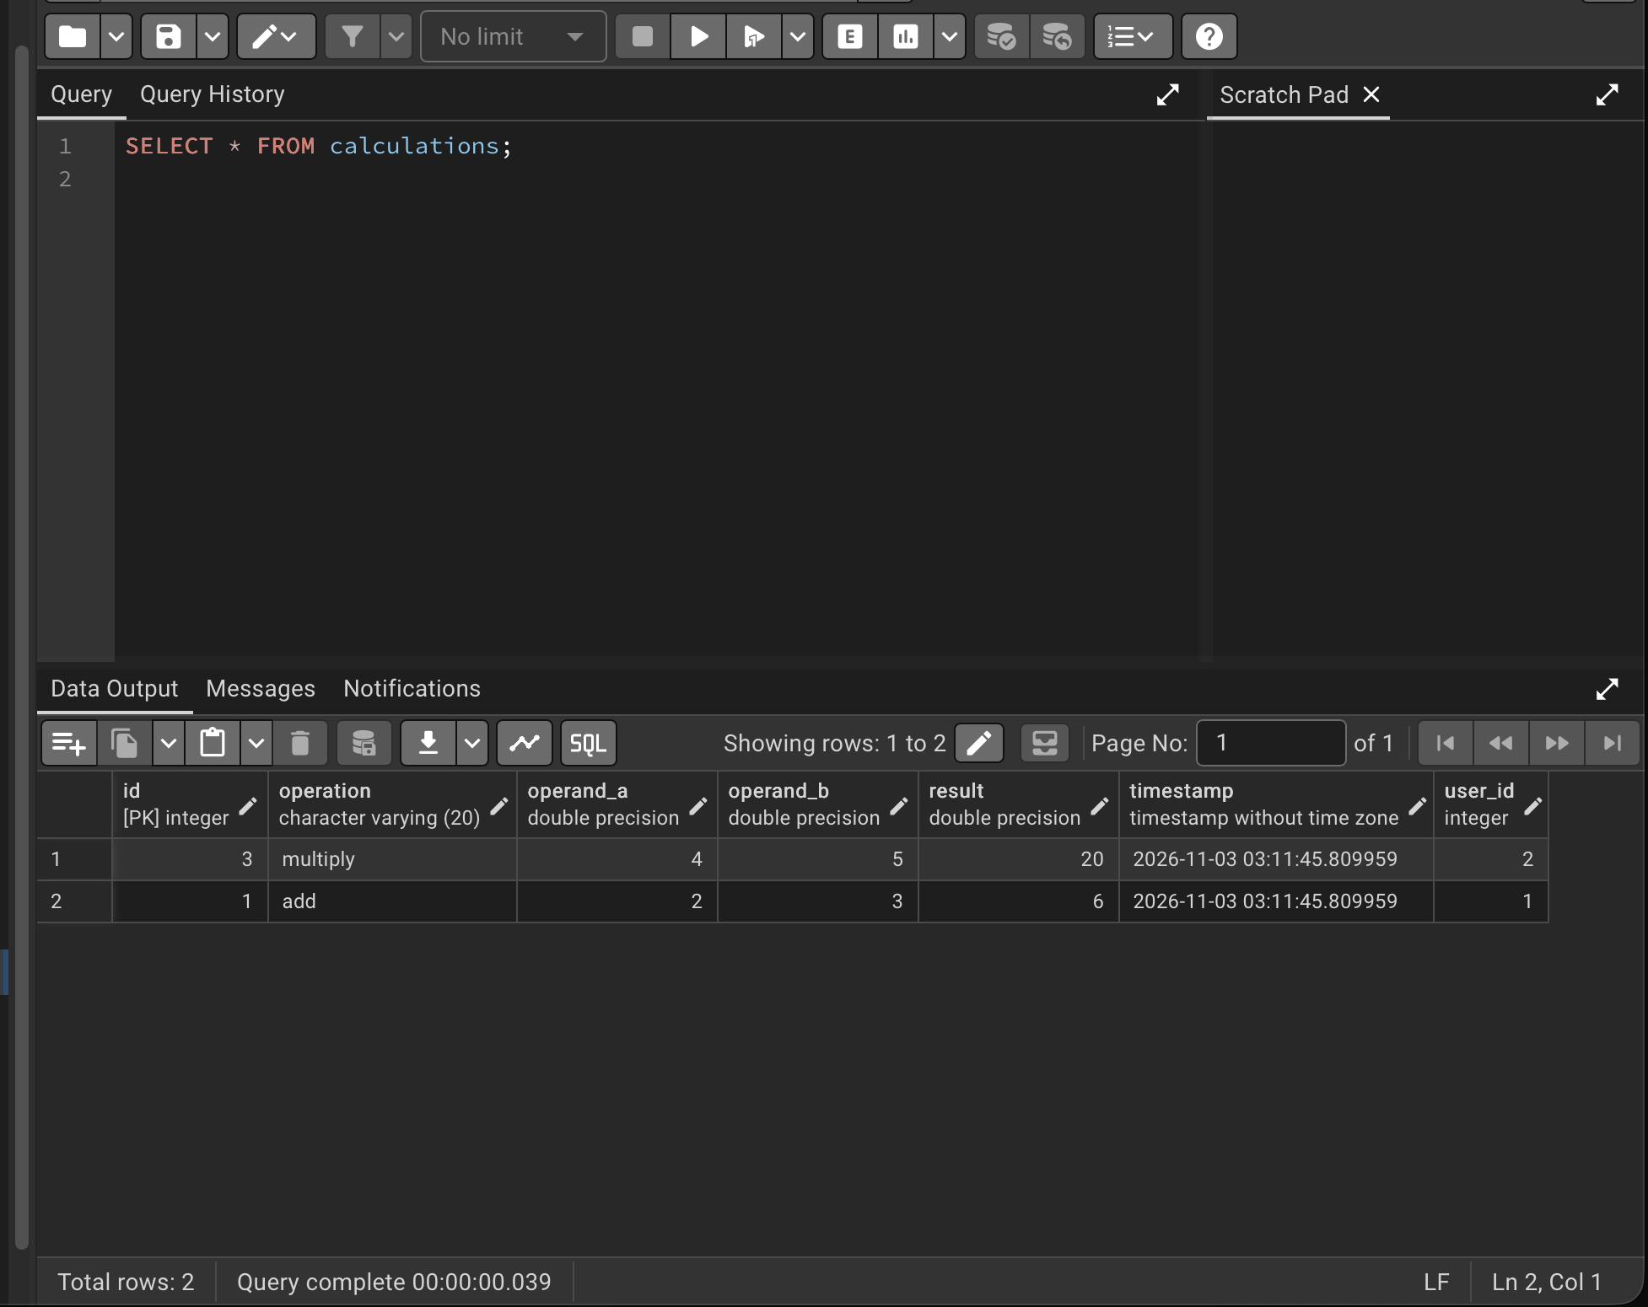

Successful run of Docker Compose services.
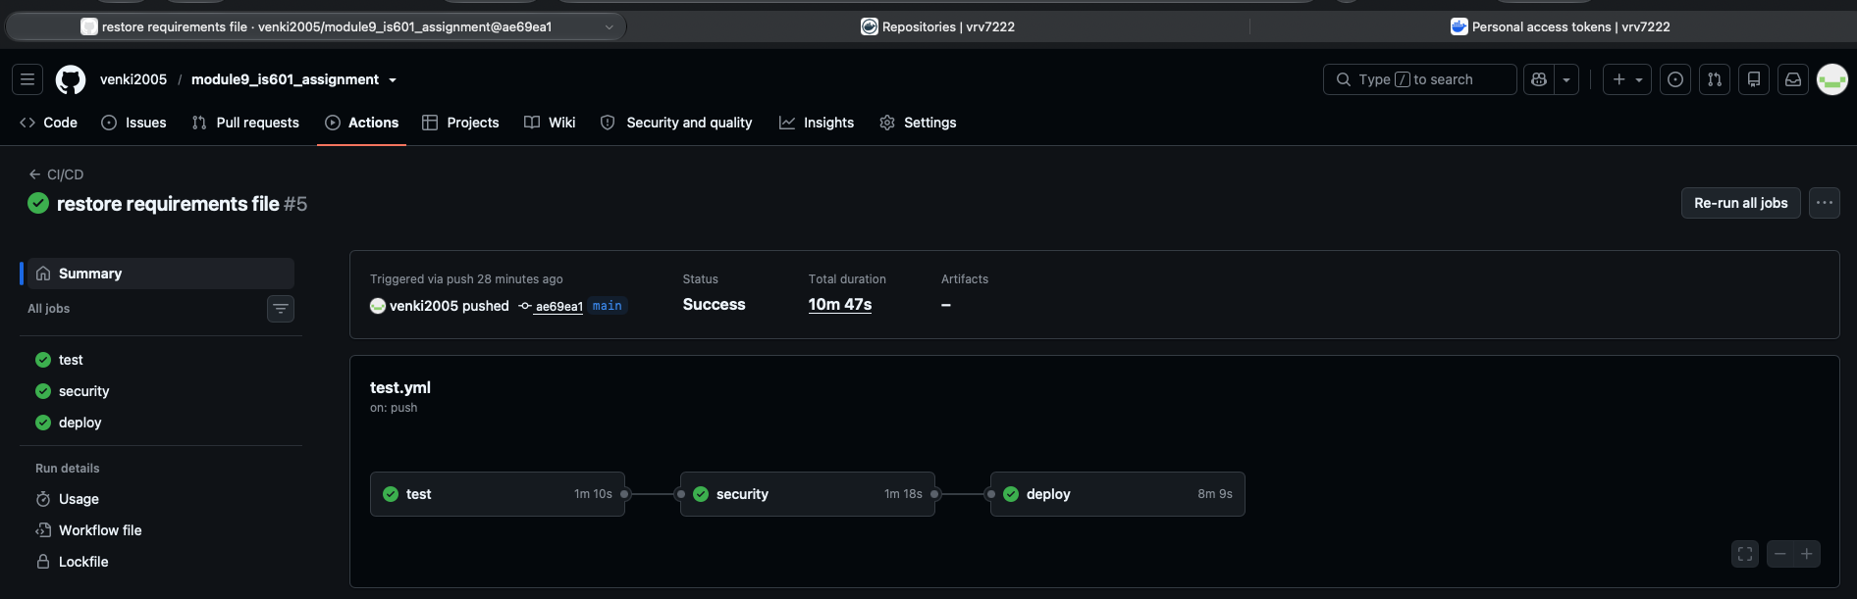

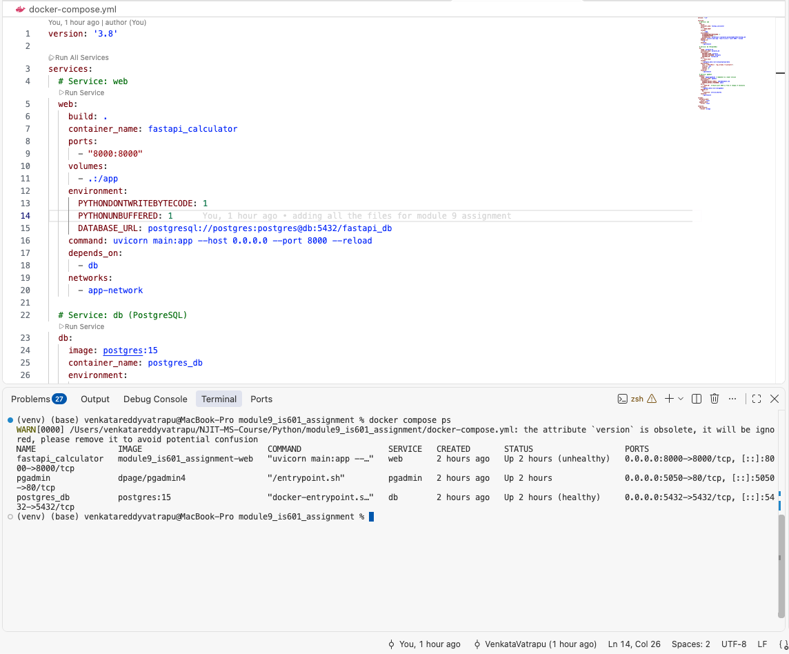

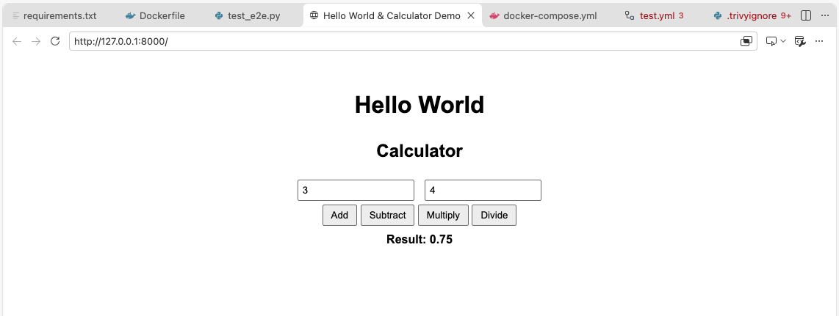

Assignment Reflection

This assignment gave me valuable hands-on experience with PostgreSQL and built on my previous experience with Microsoft SQL Server, MySQL, MongoDB, and Oracle SQL. Following the steps in the lecture video made configuring PostgreSQL, FastAPI, and pgAdmin within Docker straightforward. Initially, I encountered challenges with the Docker image tag, an error indicating that a container name was already in use, and synchronization during end-to-end (E2E) testing. Working through these issues gave me practical troubleshooting experience and helped me feel more comfortable with the setup. Overall, this assignment was a rewarding learning experience, and I finished feeling more confident working with PostgreSQL and the supporting tools.

